Qn) **Defined Robot by Robotics Industry Association (RIA)** as

*A re-programmable, multifunctional manipulator designed to move material, parts, tools or specialized devices through variable programmed motion for a variety of tasks.*

Qn) **Robotic System**

A Robotic system, consists of the following elements, which are integrated to form a whole:

Manipulator / Rover: This is the main body of the Robot and consists of links, joints and structural elements of the Robot.

End Effector: This is the part that generally handles objects, makes connection to other machines, or performs the required tasks. It can vary in size and complexity from a end-effector on the space shuttle to a small gripper.

**Accessories**

Actuators: Actuators are the muscles of the manipulators. Common types of actuators are servomotors, stepper motors, pneumatic cylinders etc.

Sensors: Sensors are used to collect information about the internal state of the robot or to communicate with the outside environment. Robots are often equipped with external sensory devices such as a vision system, touch and tactile sensors etc which help to communicate with the environment.

Controller: The controller receives data from the computer, controls the motions of the actuator and coordinates these motions with the sensory feedback information.

Qn) **World Reference Frame** which is a universal coordinate frame, as defined by the x-y-z axes. In this case the joints of the robot move simultaneously so as to create motions along the three major axes.

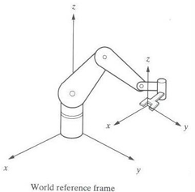

Qn) **What is the definition of robot proposed from BRA() ?**

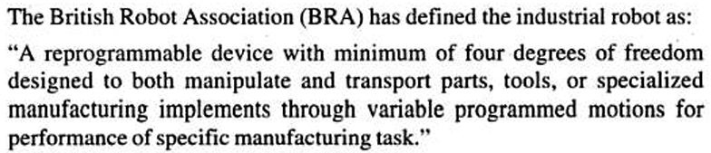

Qn) **Robot Anatomy**

The anatomy of a robot consists of various essential components that work together to provide motion and functionality. These components define the robot's structure, movement, and interaction with the environment.

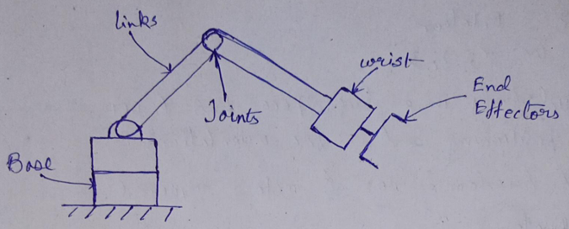

**(i)Base**

* **Definition**: The base is the stationary or mobile platform that supports the entire robotic structure.
* **Functions**:
  + Provides stability and anchors the robot to the ground.
  + Acts as the foundation for all links and joints.
* **Types**:
  + **Fixed base**: Used in industrial robots (e.g., robotic arms).
  + **Mobile base**: Used in mobile robots, such as autonomous vehicles or wheeled robots.
* **Example**: The base of a robotic arm is typically bolted to a workstation.

**(ii)Links**

* **Definition**: Links are rigid members that connect different joints of the robot.
* **Functions**:
  + Serve as the structural components of the robot.
  + Transfer motion from one joint to another.
  + Provide mechanical strength and rigidity.
* **Characteristics**:
  + Links can vary in size, shape, and material, depending on the robot's application.
  + May include additional elements like sensors or tools mounted on them.
* **Example**: In a robotic arm, links are the sections between the shoulder, elbow, and wrist joints.

**(iii)Joints**

* **Definition**: Joints are movable connections between links that allow relative motion.
* **Functions**:
  + Facilitate movement of the robot by providing degrees of freedom (DOF).
  + Determine the robot's kinematic structure and workspace.
* **Types of Joints**:
  + **Rotational Joint (R)**: Allows rotation about a single axis.
  + **Prismatic Joint (P)**: Allows linear motion along a single axis.
  + **Spherical Joint**: Allows motion in multiple directions (used in humanoid robots).
  + **Cylindrical Joint**: Combines rotational and prismatic motion.
  + **Planar Joint**: Allows motion in a plane.
* **Example**: The shoulder joint of a robot arm is a rotational joint.

**(iv)Wrist**

* **Definition**: The wrist is the part of the robot located between the last link and the end effector.
* **Functions**:
  + Provides precision in positioning and orienting the end effector.
  + Enhances dexterity by allowing complex maneuvers.
* **Characteristics**:
  + Typically has 2-3 degrees of freedom (e.g., pitch, yaw, and roll).
  + Compact and lightweight to minimize inertia.
* **Example**: A robotic wrist might rotate to align a gripper with a specific object.

**(v)End Effectors**

* **Definition**: The end effector is the tool or device mounted at the end of the robotic arm or wrist that interacts with the environment.
* **Functions**:
  + Performs tasks such as gripping, welding, painting, or assembly.
  + Adapts to specific tasks using interchangeable tools.
* **Types of End Effectors**:
  + **Grippers**: For picking and placing objects (e.g., mechanical, vacuum, or magnetic grippers).
  + **Tools**: For specialized operations like welding torches, drills, or screwdrivers.
  + **Sensors**: For measuring or inspecting objects (e.g., cameras or force sensors).
* **Example**: A robotic gripper used for packaging items in a factory.

|  |  |  |  |
| --- | --- | --- | --- |
| **Component** | **Description** | **Function** | **Example** |
| Base | Foundation of the robot | Provides stability or mobility | Fixed base of a robotic arm |
| Links | Rigid structural elements | Transfers motion between joints | Arm sections of a robot |
| Joints | |  | | --- | | Movable connections between links |  |  | | --- | |  | | Provides degrees of freedom | Rotational shoulder joint |
| Wrist | Connection between the last link and end effector | Enhances precision and dexterity | Robot wrist for alignment |
| End Effectors | Tools or devices attached at the wrist | Performs specific tasks | Grippers, welders, or sensors |

Qn) **Wrist Configuration of a Robot**

(Note: If this question will come in the exam then you can write the above mentioned wrist point but don’t forget to draw the wrist diagram. This is same for all types of configurations of the robot)

The **wrist configuration** of a robot refers to the arrangement of joints and degrees of freedom (DOF) in the robot's wrist, located between the last link and the end effector.

**Key Features**

**Degrees of Freedom**:

* + A typical robotic wrist provides 2 or 3 degrees of freedom:
    - **Pitch**: Up and down tilting motion.
    - **Yaw**: Left and right turning motion.
    - **Roll**: Rotational motion about the wrist axis.

**Types of Wrist Joints**:

* **Spherical Wrist**: Combines multiple rotational joints to provide a full range of motion.
* **Articulated Wrist**: Uses distinct rotational axes for each movement (e.g., pitch, yaw, roll).

**Actuation**:

* Wrist movements are driven by actuators (electric, pneumatic, or hydraulic), ensuring smooth and accurate control.

**Functions**

* **Orientation**: Aligns the end effector to the desired angle for specific tasks.
* **Precision**: Enables the robot to handle delicate or complex operations with accuracy.
* **Flexibility**: Allows the end effector to access hard-to-reach areas and perform complex maneuvers.

**Applications**

* Used in robots for tasks like assembly, welding, painting, surgery, and material handling, where precise end-effector orientation is crucial.

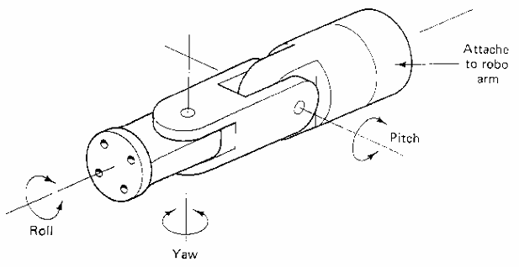

Qn) **Write a MATLAB program to animate two-link robot.**

(Ignore the hand written code)

a1=1;

a2=1;

th1max = 180;

th2max = 90;

th1 = 0:th1max/100:th1max;

th2 = 0:th2max/100:th2max;

xmin = -1.5*(a1+a2);

ymin = -1.5*(a1+a2);

xmax = 1.5*(a1+a2);

ymax = 1.5*(a1+a2);

for i=1:101

x1(i)=a1*cos(th1(i)*pi/180);

y1(i)=a1*sin(th1(i)*pi/180);

x2(i) = a1*cos(th1(i)*pi/180)+a2*cos((th1(i)+th2(i))*pi/180);

y2(i) = a1*sin(th1(i)*pi/180)+a2*sin((th1(i)+th2(i))*pi/180);

plot([0, x1(i), x2(i)],[0, y1(i), y2(i)])

hold on

plot([0, x1(i), x2(i)],[0, y1(i), y2(i)],'o')

hold off

axis([xmin xmax ymin ymax])

axis("square")

drawnow

end

Qn) **Write a MATLAB program to animate one-link robot.**

(Ignore the hand written code)

a1 = 1;

th1max = 360;

th1 = 0:th1max/100:th1max;

xmin = -1.5 * a1;

ymin = -1.5 * a1;

xmax = 1.5 * a1;

ymax = 1.5 * a1;

for i = 1:101

    x1 = a1 * cos(th1(i) * pi / 180);

    y1 = a1 * sin(th1(i) * pi / 180);

    plot([0, x1], [0, y1], 'b-', 'LineWidth', 2);

    hold on;

    plot(x1, y1, 'ro', 'MarkerSize', 8, 'MarkerFaceColor', 'r');

    hold off;

    axis([xmin xmax ymin ymax]);

    axis square;

    grid on;

    drawnow;

end

Qn) **Write a note on robot programming language.**

(You can read any one answer of this question. Either handwritten or this)

A robot programming language is a specialized coding language used to instruct a robot on how to perform specific tasks by defining its movements, actions, and interactions with its environment, essentially acting as the communication bridge between a computer and a robotic system.

Key Points about Robot Programming Languages:

* Variety of Languages:

While there isn't one single "robot programming language," several general-purpose languages like C/C++, Python, Java, and MATLAB are widely used in robotics due to their flexibility and powerful capabilities.

* Manufacturer-Specific Languages:

Many industrial robot manufacturers also provide their own proprietary programming languages, which are often designed to work specifically with their robot models and control systems, requiring familiarity with the specific robot brand.

* Low-Level Control:

For tasks requiring precise control over robot hardware, languages like C/C++ are preferred as they allow direct access to low-level hardware components like sensors and actuators.

* High-Level Abstraction:

Languages like Python are often used for developing more complex robotic behaviors, utilizing libraries for tasks like computer vision, path planning, and machine learning, due to their ease of use and readability.

Common Applications of Robot Programming:

* Industrial Automation: Programming robots to perform repetitive tasks like welding, painting, assembly, and material handling in manufacturing environments.
* Logistics and Warehousing: Programming robots to move and sort packages in warehouses.
* Medical Robotics: Programming surgical robots to perform precise procedures.
* Autonomous Vehicles: Programming self-driving cars to navigate and interact with their surroundings.

Qn) **Write the classification of sensors.**

(I will suggest you to read this answer but if you have already studied the handwritten then that’s okay)

Sensors can be classified based on their operating principle, output type, and energy consumption, with the primary categories being: Active Sensors, Passive Sensors, Analog Sensors, and Digital Sensors.

Based on Energy Consumption:

* **Active Sensors:**

These sensors require an external power source to operate, emitting energy to detect a stimulus and measure its response. Examples include ultrasonic sensors, infrared sensors, and radar sensors.

* **Passive Sensors:**

These sensors don't need an external power source, instead relying on changes in their own electrical properties when exposed to a stimulus. Examples include thermistors (temperature sensing) and photoresistors (light sensing).

Based on Output Signal:

* **Analog Sensors:**

These sensors produce a continuous, variable output signal that can take on any value within a specific range. Examples include potentiometers, strain gauges, and pressure transducers.

* **Digital Sensors:**

These sensors provide a discrete output signal, usually in the form of a binary "on" or "off" state. Examples include proximity sensors, limit switches, and optical encoders.

Common Sensor Types:

* **Temperature Sensors:** Measure temperature changes using elements like thermistors, thermocouples, or resistance temperature detectors (RTDs)
* **Light Sensors:** Detect light intensity using photodiodes, photoresistors, or phototransistors
* **Pressure Sensors:** Measure pressure variations using piezoelectric or capacitive principles
* **Motion Sensors:** Detect movement using technologies like infrared, ultrasonic, or Doppler radar
* **Force Sensors:** Measure applied force using strain gauges or piezoelectric transducers
* **Chemical Sensors:** Detect the presence or concentration of specific chemicals through various mechanisms like electrochemical or optical reactions
* **Magnetic Sensors:** Detect magnetic fields using Hall effect sensors or magnetoresistance
* **Accelerometers:** Measure acceleration and changes in velocity